Software Design Document
NetSentrix
Network Monitoring & Intrusion Detection System

Submitted by
Izat Ullah (S23BINFT1M01162)

Submitted to
Ma’am, Musarat Karim

Department of Information Technology
Faculty of Computing
The Islamia University of Bahawalpur

Summary
NetSentrix is a real-time NIDS (Network Monitoring and Intrusion Detection System), which has been designed as a software-only application capable of being installed in institutional and campus networks such as the network of The Islamia University of Bahawalpur. The proposed NIDS is a web-based software solution, which involves the passive capturing and analyzing of live network traffic, detecting any suspicious activity and attacks, keeping track of connected devices and open ports, and generating instant alerts to administrators via a web-based interactive dashboard.
This Software Design Document (SDD) converts the software requirements outlined in NetSentrix Software Requirement Specification (SRS) into actual architecture design and detailed design of the application. This document highlights the high-level design of the NetSentrix application architecture, data model schema with an entity-relationship diagram, as well as its user interface and layout design.
The technology stack for developing this application includes React.js for frontend dashboard development, Flask as the Python backend, Scapy for capturing packets at a low level, Nmap for scanning networks and open ports, MySQL as the relational database management system, and Flask-SocketIO for websockets. NetSentrix uses four-layered application architecture.
The security design of NetSentrix is built around five rule-based intrusion detection mechanisms that operate in real time against the live packet stream. The system detects SYN flood attacks by monitoring abnormal rates of TCP SYN packets from a single source, identifies port scanning attempts by tracking the number of distinct destination ports contacted within a sliding time window, detects ARP spoofing by maintaining a binding table of IP-to-MAC address mappings and flagging any conflict, recognises ICMP flood attacks through packet rate thresholds, and identifies SSH and FTP brute force attempts by counting repeated failed connection attempts. Each detected event is classified by severity as Low, Medium, High, or Critical, immediately persisted to the database, pushed to the administrator dashboard in real time through a WebSocket connection, and, for High and Critical events, dispatched as an email notification to all configured recipients via SMTP.
The data management and reporting subsystem ensures that all network activity is fully auditable and exportable. Every captured packet summary is stored in the MySQL database with a complete set of fields including source and destination addresses, protocol, port numbers, and timestamp, allowing administrators to search and filter the full traffic history using date ranges, IP addresses, protocol types, and port numbers. Detected alerts are logged with their full context for post-incident investigation. Administrators can generate structured reports covering network traffic summaries, alert histories, and device inventories, and export them in PDF, CSV, or JSON format. A scheduled log rotation job automatically archives records older than the configured retention period to prevent database overflow, ensuring the system remains performant throughout its operational lifetime.
Table of Contents
- Application Architecture………………………………………………………………… 4
1.1. Architecture Diagram……………………………………………..…………… 4
1.2. Architectural Pattern…………………………………………………………… 6
1.3. Backend Controllers and Their Functions…………………………………… 6
1.3.1. AuthService…………………………………………………………… 6
1.3.2. CaptureEngine and PacketProcessor…………………………………… 6
1.3.3. DeviceScanner………………………………………………………… 7
1.3.4. AttackDetector………………………………………………………… 7
1.3.5. AlertEngine…………………………………………………………… 7
1.3.6. ReportService………………………………………………………… 7
1.4. External APIs and Libraries………………………………………………… 8
1.5. Sequence Diagram: Packet Capture to Dashboard Update………………… 8
1.6. Sequence Diagram: User Login……………………………………………… 9
1.7. Coding Conventions…………………………………………………………... 11
- Data Model Schema…………………………………………………………………… 11
2.1. Entity Descriptions…………………………………………………………… 12
2.1.1. users…………………………………………………………………… 12
2.1.2. devices………………………………………………………………… 12
2.1.3. ports…………………………………………………………………… 12
2.1.4. traffic_logs…………………………………………………………… 12
2.1.5. alerts…………………………………………………………………… 12
2.1.6. archive_logs…………………………………………………………… 12
2.2. Entity Relationships………………………………………………………… 12
2.3. ER Diagram………………………………………………………………….. 13
2.4. Indexing Strategy……………………………………………………………… 13
- User Interface………………………………………………………………………… 14
3.1. Design Philosophy and Visual Style……………………………………… 14
3.2. Screen Inventory……………………………………………………………… 14
3.2.1. Login Screen (/login)………………………………………………… 14
3.2.2. Main Dashboard (/dashboard)………………………………………… 15
3.2.3. Device Inventory (/devices)…………………………………………… 16
3.2.4. Device Detail (/devices/:id)…………………………………………… 16
3.2.5. Alerts Log (/alerts)…………………………………………………… 16
3.2.6. Traffic Logs (/traffic)………………………………………………… 17
3.2.7. Reports (/reports)……………………………………………………… 17
3.2.8. Settings (/settings)…………………………………………………… 17
3.3. Navigation Structure………………………………..………………………… 17
- Application Architecture
NetSentrix uses a four-tier architecture. Each tier has a job and talks to the tier next to it through clear interfaces. This separation helps the packet capture engine work on its own. Keeps the frontend dashboard separate from the analysis logic.
The four tiers are:
* The Capture and Analysis Tier at the bottom which handles raw network access using tools like Scapy and Nmap.
* The Application Tier in the middle built on Flask and Flask-SocketIO which handles all business logic, API endpoints and real-time event dispatch.
* The Data Tier, which uses MySQL 8 and SQLAlchemy to store traffic logs, device records, alerts and user accounts.
* The Presentation Tier at the top a React.js single-page application that shows the dashboard device grid, alert feed and report screens.
1.1 Architecture Diagram
The following diagram shows how NetSentrix works at runtime with the four tiers interacting and using technologies.
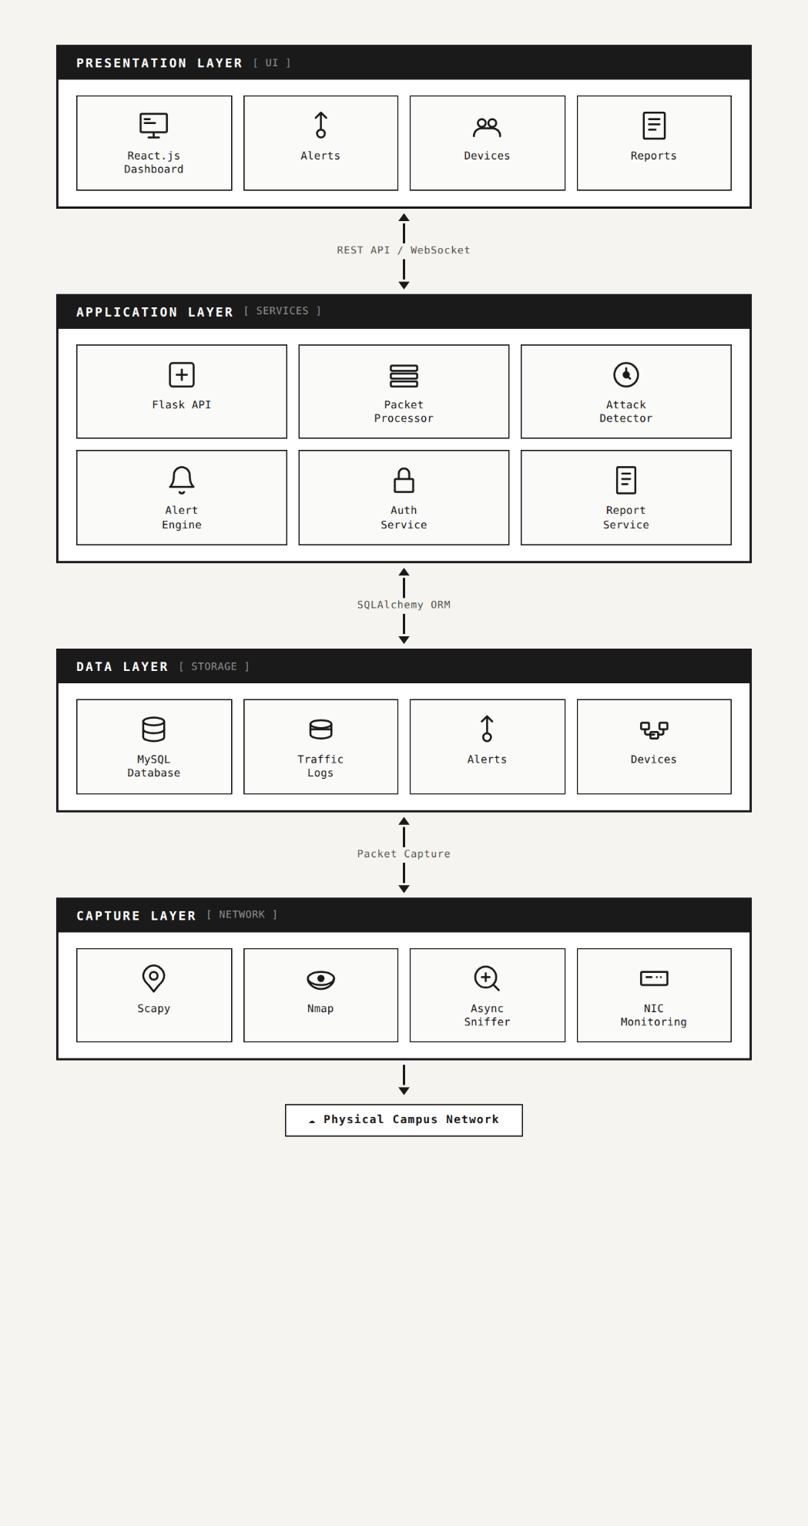
1.2 Architectural Pattern
The application follows the Model-View-Controller (MVC) pattern on the backend. On the backend Models are SQLAlchemy classes that represent database entities. Views are the Flask route handlers and SocketIO event handlers that turn responses into a format. Controllers are service classes like AuthService, CaptureEngine and PacketProcessor that contain business logic.
On the frontend React components act as both the View and Controller in a one-way data flow. The application state, such as authentication credentials and the live alert feed is managed using React Context and the useReducer hook. Local component state, like filter inputs and pagination is handled with useState and useEffect hooks. All API communication is handled in one Axios instance with JWT interceptors.
1.3 Backend Controllers and Their Functions
1.3.1 AuthService
The AuthService handles all authentication and authorization logic. Here are its main functions:
Login
This function takes a username and password. It checks the password against the one stored in the database. If its correct it gives a token that lasts 15 minutes and another token that can be used to get a new token within 7 days.
Logout
This function stops a token from being used by adding it to a list of blocked tokens.
Refresh
This function checks if a token is valid and gives a token if it is.
Lockout_check
This function checks how times someone has tried to log in with the wrong password. If its than 5 times it locks the account for 15 minutes.
1.3.2 CaptureEngine and PacketProcessor
The CaptureEngine manages a tool that captures network data.
Start: This function starts capturing data from a specific network connection.
stop: This function stops capturing data. Removes any data that was captured but not processed.
The PacketProcessor takes the captured data breaks it down and understands what it means.
It finds the MAC addresses, IP addresses and other details in the data.
It then updates some numbers that show whats happening on the network and saves summaries of the data to the database.
1.3.3 DeviceScanner
The DeviceScanner. Learns about all devices on the network it's monitoring.
Run_arp_scan: This function sends out messages to find devices on the network. Makes a list of them.
run_nmap_scan: This function checks a device to see what ports are open and what kind of operating system its using.
get_vendor: This function looks up who made a device based on its MAC address.
The DeviceStatusMonitor checks every 60 seconds to see which devices are still working.
1.3.4 AttackDetector
The AttackDetector looks for signs of attacks on the network using five methods:
SYNFloodDetector: It checks for too many connection requests from one device, which could be a sign of a SYN flood attack.
PortScanDetector: It checks if one device is trying to connect to other devices, which could be a sign of a port scan.
ARPSpoofDetector: It checks if someone is trying to pretend to be another device on the network.
ICMPFloodDetector: It checks for many ICMP messages, which could be a sign of an ICMP flood attack.
BruteForceDetector: It checks for many failed login attempts, which could be a sign of a brute-force attack.
1.3.5 AlertEngine
The AlertEngine handles alerts when the AttackDetector finds something
* It creates an alert with details about the attack.
* It saves the alert to the database.
* It sends the alert to anyone who is watching the network.
* For alerts it also sends an email.
1.3.6 ReportService
The ReportService makes reports, about what happened on the network.
* **Generate**: This function makes a report based on what the user wants.
* The report can be turned into a PDF, CSV or JSON file.
* There's also a job that runs every day to clean up data and prevent the database from getting too big.
1.4 External APIs and Libraries
The NetSentrix system uses Scapy, which's a library for Python. This library helps with packet manipulation. We use Scapy to capture and craft packets. The AsyncSniffer class in Scapy is used by NetSentrix to capture packets in time. This happens on the network interface that we have set up. Scapy can also decode types of network layers like Ethernet and IP. The PacketProcessor uses these decoders directly.
We also use Nmap, which's a tool for scanning networks. The python-nmap library helps us use Nmap from our Python code. When we call Nmap we use flags like -sS for scanning and -O for finding out what operating system is running. We also use the flag to find out what version of a service is running. The results from Nmap are stored in a way and saved in our database.
The Flask-SocketIO library helps us use the Socket.IO protocol with Flask. This library uses an eventlet-based worker to handle WebSocket connections at the same time. Our server has two namespaces: one for traffic statistics and device status and one, for real-time alerts. The client library is bundled with our React frontend. Can reconnect automatically if the connection is lost.
We use Flask-JWT-Extended to manage authentication. This library provides decorators that we can use to check if a user is authenticated. We also use a database to keep track of tokens that're no longer valid. This helps keep our system secure.
The WeasyPrint library is used to convert HTML and CSS documents to PDF files. We use Jinja2 templates to format our report data. Then WeasyPrint converts it to a PDF file that can be downloaded.
Finally we use SQLAlchemy as our ORM layer. This means we define our database models as Python classes. We also use Alembic to make changes to our database schema without losing any data.
1.5 Sequence Diagram: Packet Capture to Dashboard Update
The following sequence diagram shows the flow of data from the moment a packet is captured on the network interface to the moment the dashboard is updated.
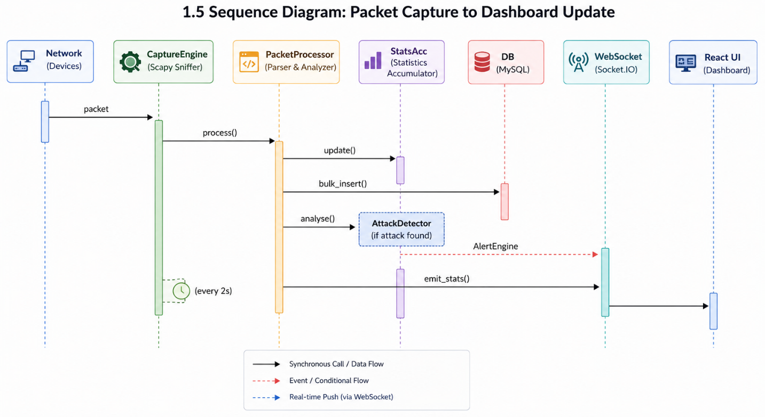
This sequence diagram illustrates the complete flow of data from packet capture to real-time dashboard updates in NetSentrix. The process starts when a network packet is captured by the CaptureEngine. The captured packet is then forwarded to the PacketProcessor, where the packet is processed and analyzed. After processing, the statistics are updated in the StatsAcc module, while packet information is simultaneously stored in the database using the bulk_insert() operation. The PacketProcessor also sends packet data to the AttackDetector for threat analysis. If any suspicious activity or attack is detected, the AlertEngine immediately forwards an alert to the WebSocket service. Every two seconds, the updated statistics are emitted through the WebSocket connection and displayed on the React-based dashboard interface, allowing administrators to monitor live traffic and security events in real time.
1.6 Sequence Diagram: User Login
The following sequence diagram shows the authentication flow when a user attempts to log in.
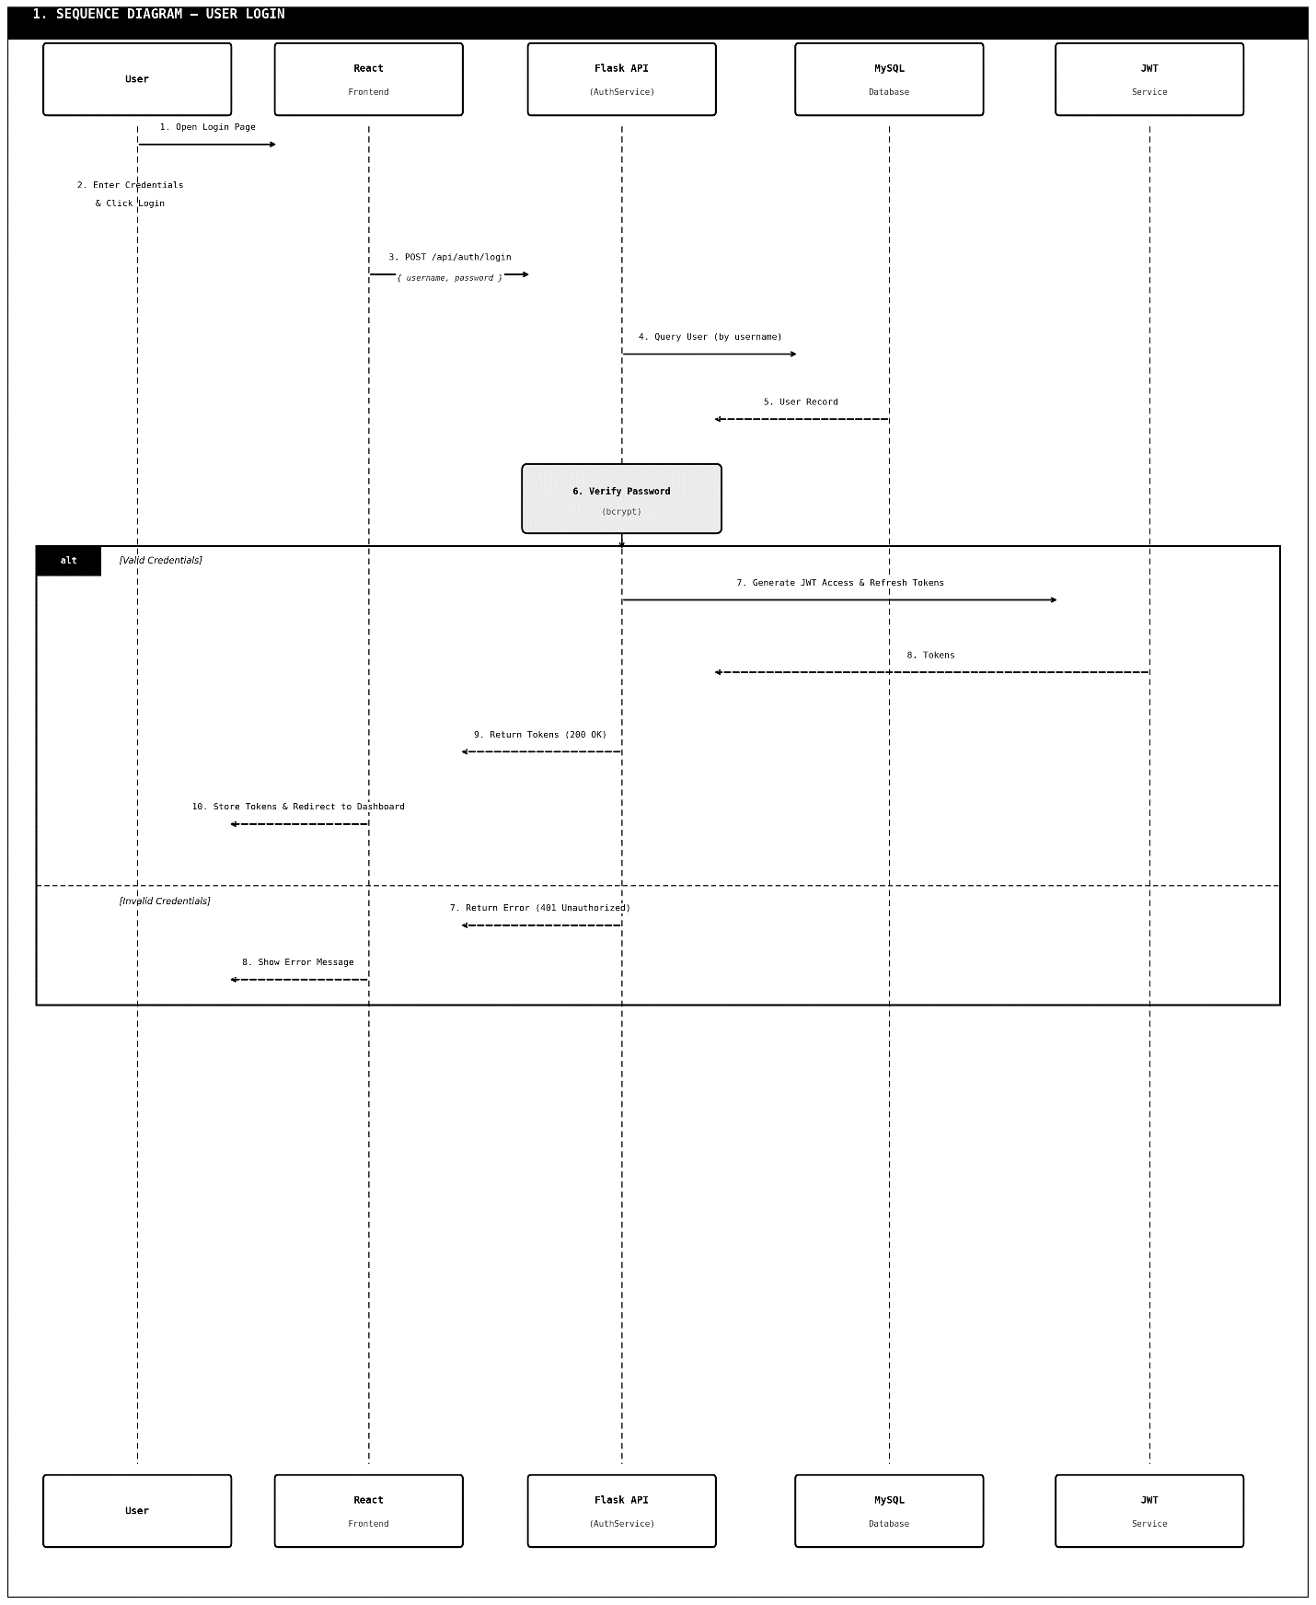
This sequence diagram shows how a user logs in to NetSentrix.
The process starts when the browser sends a POST request with the username and password to the Flask login endpoint.
* The Flask backend then sends these credentials to the AuthService.
* The AuthService asks the database for the users record.
* The entered password is checked against a bcrypt password hash.
If the password is correct
the system updates the users login time in the database.
The system also creates JWT access and refresh tokens.
* These tokens are sent back to the Flask authentication endpoint.
* The endpoint then sends a response back to the browser with the authentication tokens.
If the login credentials are not valid
the system counts the failed login attempts.
It checks if the account should be locked.
The system returns an error response, to the user.
1.7 Coding Conventions
Our Python code for the backend is written in a way that follows the PEP 8 style guidelines. We use snake_case for all our module names and variable names. For class names we use PascalCase. We write our constants in UPPER_SNAKE_CASE. Every function we write includes a description of what parameters it needs and what it returns. We make sure our service classes do not depend on the Flask request context so we can test them on their own.
Our JavaScript code for the frontend is written in a way that follows the Airbnb React style guide. We name our component files using PascalCase. For hooks and utility functions and API client files we use camelCase. We write all our components as components and we use React hooks. We do not use class components. We declare PropTypes for all the props of our components. We store configuration that's specific to the environment, in.env files and we access it through process.env variables. We follow these rules for our frontend JavaScript code and our backend Python code.
2. Data Model Schema
NetSentrix uses a database called MySQL 8. This database is accessed through something called SQLAlchemy ORM. The database has six tables: users, devices, ports, traffic_logs, alerts and archive_logs. Each of these tables has a column that shows when it was created. Some tables also have a column that shows when they were last updated.
2.1 Entity Descriptions
2.1.1 users
The users table is for people who can use the NetSentrix dashboard. This includes administrators and analysts. Each user has an username and a secret password. The role of each user can be one of four things: admin, admin, analyst or viewer. We also store the users email address so we can send them alerts. If someone tries to log in many times with the wrong password their account will be locked. We also keep track of when each user logged in.
2.1.2 devices
The devices table is for all the devices on the network. Each device has an IP address. When we find a device we try to figure out its mac address, hostname and vendor. We also try to guess what kind of operating system it is using. The status of each device can be online, offline or warning. This status is updated every sixty seconds. We also keep track of when we saw each device and when we last saw it.
2.1.3 ports
The ports table is for all the ports on each device. Each port belongs to one device. We keep track of the port number, the protocol (like TCP or UDP) and whether the port's open or closed. We also try to figure out what service is using each port. For example port twenty-two is usually used for SSH and port eighty is usually used for HTTP. We keep track of when we last scanned each port.
2.1.4 traffic_logs
The traffic_logs table is the table in the database. It has one row for each packet of traffic we capture. Each row has a lot of information like the timestamp, the source and destination IP addresses the source and destination mac addresses the protocol and the length of the packet. We also keep track of some information for TCP packets. This table is indexed so we can query it quickly. If a record is older than an amount of time it gets moved to the archive_logs table.
2.1.5 alerts
The alerts table is for all the security events we detect. Each alert has a type, like SYN_FLOOD or ARP_SPOOF. It also has the IP address of the device that caused the alert the IP address of the target device and a severity level. The severity level can be low, medium, high or critical. We also keep track of whether we sent an email about the alert. Each alert has a timestamp.
2.1.6 archive_logs
The archive_logs table is like the traffic_logs table. It has all the columns. We use it to store traffic logs that we don't need to query anymore. This keeps the traffic_logs table small and fast. We move records to the archive_logs table once they are older than an amount of time.
2.2 Entity Relationships
The devices table is the table in the database. The ports table is related to the devices table because each device can have ports. The traffic_logs and alerts tables are not directly related to the devices table. They do reference IP addresses that are, in the devices table. The users table is not related to any table.
2.3 ER Diagram
The following Entity-Relationship diagram shows the structure of the NetSentrix database schema and the relationships between entities.
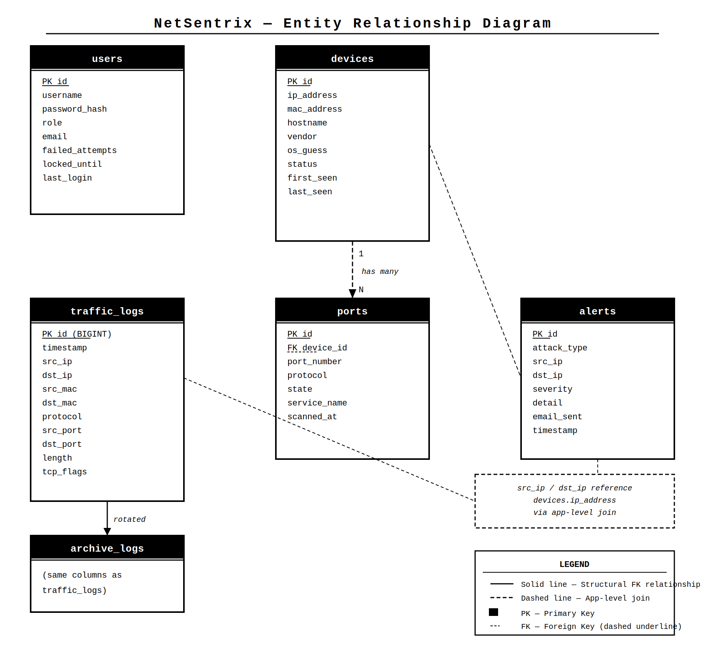
2.4 Indexing Strategy
To make sure our queries run smoothly we keep database indexes.
The traffic_logs table has an indexes.
* A BTREE index on the timestamp column helps us quickly find logs from a time period for reports.
The timestamp column is really important for getting the logs fast.
* We also have an index on src_ip and protocol.
This helps with searches that filter by these two things.
* Another BTREE index on dst_port helps us analyze traffic by port.
The alerts table also has some indexes.
* A BTREE index on timestamp helps us filter alerts by time.
* A composite index on attack_type and severity helps us filter alerts in the log view.
The devices table has an index on ip_address.
This index helps us quickly find devices, by IP and makes sure each IP is only used once.
3. User Interface
The NetSentrix user interface is a website that's easy to use and works on one page. It was built with React 18. Is run by Nginx. The website uses React Router version six to help people move around the site. The people who made the site wanted to make sure it was easy for network administrators to see the security of the network at a glance. The site works on desktop and laptop computers with a screen that is at least 1280 pixels wide because network monitoring is usually done on a computer.
3.1 Design Philosophy and Visual Style
The overall design of the site is clean and professional. It is meant to show information in a way. The site uses text on white and light grey backgrounds and it uses colors like green, red orange and yellow to show the status of things. The font used on the site is simple and easy to read on computers. All the text in the reports that can be downloaded uses Times New Roman at twelve points.
The site needs a screen that's at least 1280 pixels wide to work properly. The main dashboard uses a grid to organize things and the navigation and cards use a box to arrange things. All the tables on the site can be scrolled through if the screen is not wide enough.
3.2 Screen Inventory
3.2.1 Login Screen (/login)
The Login Screen is the thing people see when they try to use the site. It has the name of the site, a place to enter a username a place to enter a password a button to log in and a place to show error messages. People cannot make their accounts on the site. The Super Admin has to make them through the Settings screen.
There are some rules for the login screen: the username can only be eighty characters long. The password can only be one hundred and twenty-eight characters long. Both fields are required. The Login button is disabled while the site is checking the login information so people cannot try to log in times at the same time. If someone tries to log in five times and fails the site will show a message saying they have to wait before trying
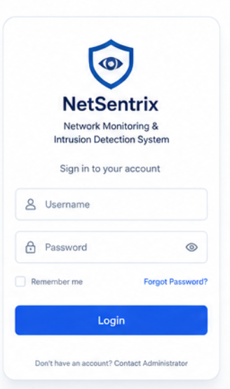
3.2.2 Main Dashboard (/dashboard)
The Main Dashboard is the screen that people see after they log in. It is meant to give them an overview of the whole network. The screen is divided into four rows.
The first row has four cards that show summary information: the number of devices on the network the number of active connections the number of alerts in the last twenty-four hours and the current network bandwidth. Each card shows a number and a label. There are no buttons or other controls on the cards.
The second row has two panels side by side. The left panel takes up sixty percent of the width. Shows a chart of the network traffic over the last sixty seconds. The right panel takes up forty percent of the width. Shows a pie chart of the different types of network traffic.
The third row has two panels. The left panel shows a table of all the devices on the network with information like IP address MAC address and status. The right panel shows a list of the recent security alerts with information like severity, attack type and timestamp.
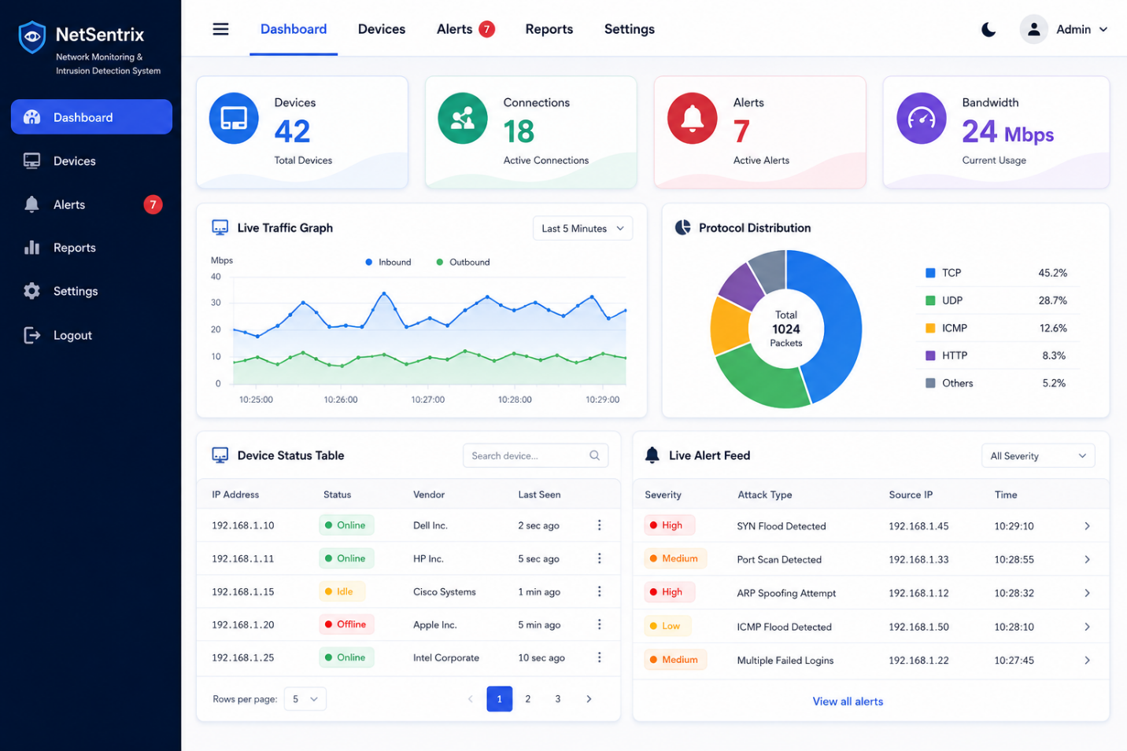
3.2.3 Device Inventory (/devices)
The Device Inventory screen shows a list of all the devices on the network. At the top of the screen there is a button to scan the network again. The table has columns for IP address MAC address, hostname, vendor and status. Each row has a link to view information about the device. The table can be. Filtered.
The Scan Network button is only available to people with Admin or Super Admin roles. The button is disabled while the scan is in progress. It becomes available again when the scan is finished.
3.2.4 Device Detail (/devices/:id)
The Device Detail screen shows all the information about a device. The top section shows the device properties, like IP address and MAC address. Below that there are tabs for ports and alerts.
3.2.5 Alerts Log (/alerts)
The Alerts Log screen shows a list of all the security alerts. The screen has a filter panel at the top, where people can choose the type of alert and the date range they want to see. Each alert can be expanded to show information.
3.2.6 Traffic Logs (/traffic)
The Traffic Logs screen shows a list of all the network traffic. The screen has a filter panel at the top, where people can choose the type of traffic and the date range they want to see. The table can be scrolled through. There are buttons to navigate through the results.
3.2.7 Reports (/reports)
The Reports screen allows people to generate and download reports. The screen has a menu to choose the type of report a date range picker and a button to generate the report. Once the report is generated there is a button to download it.
3.2.8 Settings (/settings)
The Settings screen is only available to Super Admin users. It has three sections: User Management, Detection Thresholds and Email Configuration. The User Management section shows a list of all the user accounts. There is a button to add new users. The Detection Thresholds section shows the threshold values for the attack detection rules and there is a button to save the changes. The Email Configuration section shows the email settings. There is a button to save the changes and a button to test the email.
The username field for users must be at least three characters long and at most eighty characters long and it must be alphanumeric. The password field must be least eight characters long. The threshold fields must be integers. The SMTP port field must be, between one and sixty-five thousand five hundred and thirty-five. The recipient address field must be an email address.
3.3 Navigation Structure
The application has a navigation bar on the side that you can see on all the screens when you are logged in. This navigation bar has links to things like Dashboard, Devices, Alerts, Traffic Logs, Reports and Settings. You can only see the Settings link if you are a Super Admin user. There is an indicator that shows you which page you are on right now. At the bottom of the navigation bar there is a logout button. When you click this button it logs you out. Takes you back to the Login screen.
